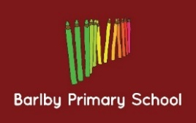
Year Group: 4
Week beginning: 06.03.17
Next week we will be learning about:
- Literacy: We will be learning about the features of playscripts.
- Maths: We are learning all about fractions this week, including finding equivalent fractions.
- Topic: This week we are researching Norman lives and writing a diary as a Norman child!

Year Group: 3
Week beginning: 06.03.17
Next week we will be learning about:
- Literacy: We will be learning about the features of persuasive leaflets.
- Maths: We are learning to solve problems involving money.
- Topic: This week we are learning about the human and animal skeletons.

