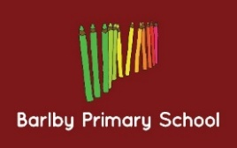
Year Group: 1
Week beginning: 06.03.2017
Next week we will be learning about:
- Literacy: We will be looking at and describing a range of settings to write our own story inspired by the story ‘Augustus and his Smile’.
- Maths: We will be consolidating our learning of measuring height, length and mass.

Year Group: 2
Week beginning: 06.03.2017
Next week we will be learning about:
- Literacy: The key features of a newspaper and how to use direct and reported speech.
- Maths: Money; we will be using different coins to make amounts, adding coins together and calculating change.

